QUESTION 1:

TRUE =1

FALSE =0

QUESTION 2 :

Three Boolean operators are AND , OR , NOT .

QUESTION 3:

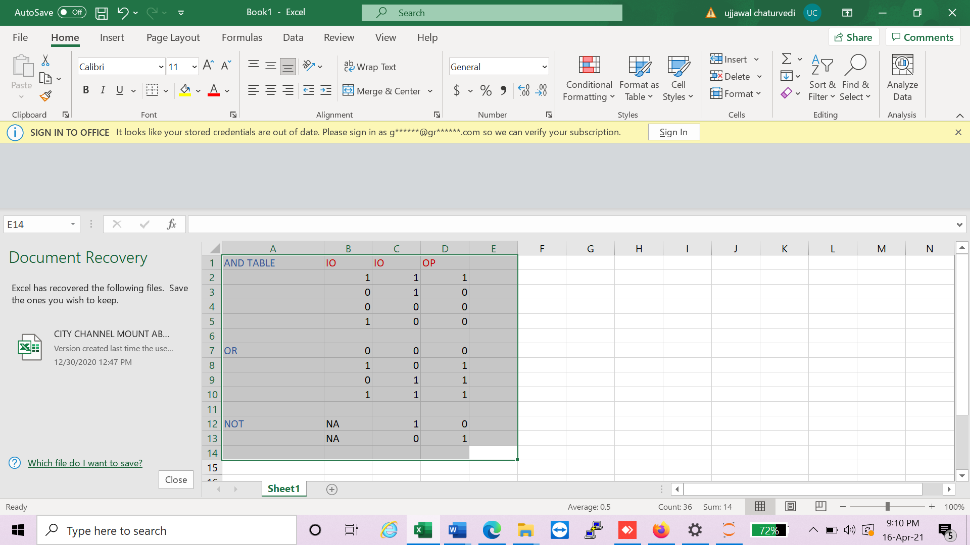

QUESTION 4

(5 > 4) and (3 == 5)

1 AND 0 , OUTPUT = 0

not (5 > 4)

OUTPUT = 0

(5 > 4) or (3 == 5) : 1 or 0 , output =1

not ((5 > 4) or (3 == 5)) , not(1 or 0), not (1), output = 0

(True and True) and (True == False) : TRUE AND FALSE : OUTPUT= FALSE

(not False) or (not True): TRUE OR FALSE = OUTPUT =TRUE

QUESTION : 5

“<=” : less than equal to

“>=” greater than equal to

“= =” equal equal to

“!=” not equal to

“<” less than

“>” greater than

QUESTION 6:

EQUAL TO OPERATOR : USED FOR COMPARISION

A = = 6

ASSSIGNMENT OPERATOR : USED FOR ASSIGNING VALUE

A= 6

------------------------------------------------------------------------------------------------------------------ ------------------------

QUESTION 7:

spam = 0

if spam == 10:

print('eggs')

END OF MODULE 1

--------------------------------------------------------------------------------------------------

if spam > 5:

print('bacon')

END OF MODULE 2

------------------------------------------------------------------------------------------------------

else:

print('ham')

print('spam')

print('spam')

END OF MODULE 3

Question no 8 :

a= int(input("enter a value "))

if a == 1:

print("HELLO")

elif a == 2:

print ("how do you do")

else:

print("greetings")

QUESTION NO 9 :

Ctrl + C is used for exit from endless loop.

Question 10 :

BREAK: it is used for coming out of the loop\

CONTINUE : it skips the current iteration in loop and goes to next iteration in same loop.

QUESTION NO 11

Range(10)

It will print from 0 to 9 as stop =10

Range (0,10)

It will print from 0 to 9 as 0 is start and 10 is stop so it will exclude 10 and print from 0 to 9 .

Range (0,10,1 )

It will print from 0 to 9 as 0 is start and 10 is stop so it will exclude 10 and print from 0 to 9, consider step as 1 .

QUESTION 12 :

For i in range(11)

print(i)

i=1

while (i < 11) :

print(i)

i=i+1

QUESTION 13:

FROM SPAM IMPORT BEACON

PRINT (BEACON(1,2))

DEF BEACON(A,B):

RETURN A+B